
Duplication Typecasting
Instructions:
Please share your answers filled inline in the word document. Submit Python code and R code files wherever applicable.

Please ensure you update all the details:
Name: _________________________
Batch Id: _______________________
Topic: Preliminaries for Data Analysis

Problem statement:
Data collected may have duplicate entries, that might be because the data collected were not at regular intervals or any other reason. To build a proper solution on such data will be a tough ask. The common techniques are either removing duplicates completely or substitute those values with a logical data. There are various techniques to treat these types of problems.

Q1. For the given dataset perform the type casting (convert the datatypes, ex. float to int)
Q2. Check for the duplicate values, and handle the duplicate values (ex. drop)
Q3. Do the data analysis (EDA)?
Such as histogram, boxplot, scatterplot etc
InvoiceNo | StockCode | Description | Quantity | InvoiceDate | UnitPrice | CustomerID | Country
536365 | 85123A | WHITE HANGING HEART T-LIGHT HOLDER | 6 | 12/1/2010 8:26 | 2.55 | 17850 | United Kingdom
536365 | 71053 | WHITE METAL LANTERN | 6 | 12/1/2010 8:26 | 3.39 | 17850 | United Kingdom
536365 | 84406B | CREAM CUPID HEARTS COAT HANGER | 8 | 12/1/2010 8:26 | 2.75 | 17850 | United Kingdom
536365 | 84029G | KNITTED UNION FLAG HOT WATER BOTTLE | 6 | 12/1/2010 8:26 | 3.39 | 17850 | United Kingdom
536365 | 84029E | RED WOOLLY HOTTIE WHITE HEART. | 6 | 12/1/2010 8:26 | 3.39 | 17850 | United Kingdom
536365 | 22752 | SET 7 BABUSHKA NESTING BOXES | 2 | 12/1/2010 8:26 | 7.65 | 17850 | United Kingdom
536365 | 21730 | GLASS STAR FROSTED T-LIGHT HOLDER | 6 | 12/1/2010 8:26 | 4.25 | 17850 | United Kingdom
536366 | 22633 | HAND WARMER UNION JACK | 6 | 12/1/2010 8:28 | 1.85 | 17850 | United Kingdom
536366 | 22632 | HAND WARMER RED POLKA DOT | 6 | 12/1/2010 8:28 | 1.85 | 17850 | United Kingdom
import pandas as pd
data = pd.read_csv("D:/Data Science/ASSIGNMENT/Assignments 3/DataSets/OnlineRetail.csv")
data.dtypes
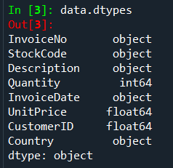

# Now we will convert 'float64' into 'int64' type.
data.UnitPrice = data.UnitPrice.astype('int64')
data.dtypes
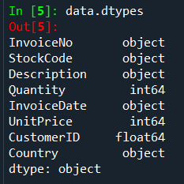
duplicate = data.duplicated()
duplicate
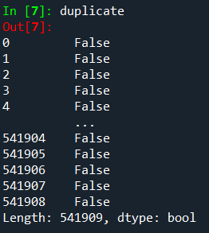
There are no duplicates in data set.

#data analysis
data.columns
data.shape# feature and target variables
data.info# basic information
data.dtypes
data.head()# displaying dataset
data.describe()#summary statistics
data.describe(include=[bool,object])
data[data['Quantity']== 1]
import seaborn as sns
sns.countplot(x=data.Quantity)

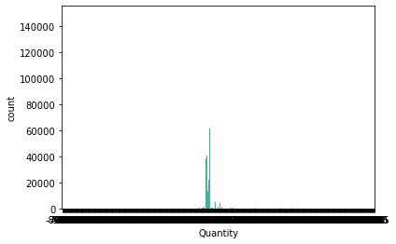

plt.hist(data.Country) #histogram

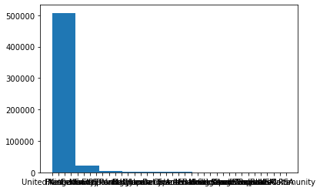
plt.boxplot(data.Quantity) #boxplot
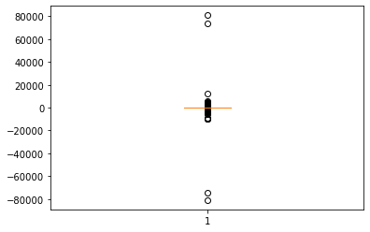

# scatter plot
plt.scatter(data['UnitPrice'], data['Quantity'])
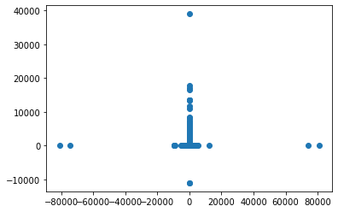

Hints:
For each assignment, the solution should be submitted in the below format
- Work on each feature of the dataset to create a data dictionary as displayed in the below image:
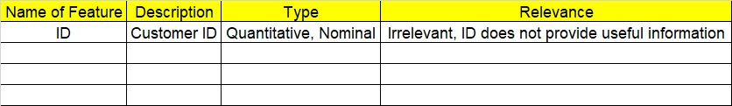
- Consider the OnlineRetail.csv dataset
- Research and perform all possible steps for obtaining solution
- All the codes (executable programs) should execute without errors
- Code modularization should be followed
- Each line of code should have comments explaining the logic and why you are using that function
Grading Guidelines:
Note: 1. An Assignment submission is considered complete only when successful executable code(s), and documentation explaining the applied solution and results are provided. Failing to submit either of them will be considered an invalid submission and will not be considered for evaluation.
2. Assignments submitted after the deadline date will affect your grades.

Grading:
Ans | Date |  |  | Ans | Date
Correct | On time | A | 100
80% & above | On time | B | 85 | Correct | Late
50% & above | On time | C | 75 | 80% & above | Late
50% & below | On time | D | 65 | 50% & above | Late
 |  | E | 55 | 50% & below
Copied/No Submission |  | F | 45

- Grade A: (>= 90): When all assignments are submitted on or before the given deadline date
- Grade B: (>= 80 and < 90):
  - When assignments are submitted on time but less than 80% of questions asked in assignments are completed. (or)
  - All assignments were submitted, however, after the given deadline

- Grade C: (>= 70 and < 80):
  - When assignments are submitted on time but less than 50% of questions asked in assignments are completed. (or)
  - Less than 80% of questions asked in assignments are submitted after the deadline

- Grade D: (>= 60 and < 70): Assignments submitted after the Deadline and with 50% or less of questions

- Grade E: (>= 50 and < 60):
  - Less than 30% of questions asked in the assignments are submitted after the deadline (OR)
  - Less than 30% of questions asked in the assignments are submitted before deadline

Grade F: (< 50): Copied submission or No submission

